**Documentation Related to the Research Work**

Now a days the challenge behind the Home Automation System is Security as there are lot of cases of Hacking the –“Home Automation System”.

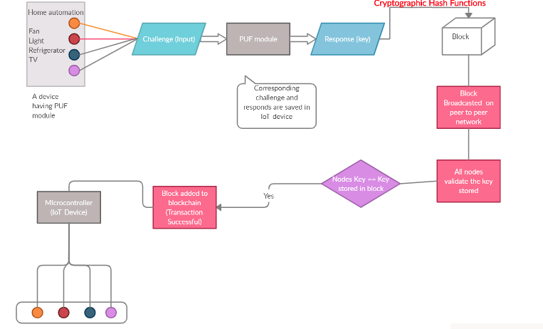

Relay

**Scenario -**

It is a Home automation system that we are securing using PUF module and Blockchain Technology.

In this Scenario we have device (may be a smart phone) integrated with PUF module on which we are having a smart Home automation app which have several buttons to control the Home appliance, each button corresponds to some challenge (or input) to perform some task, so when the PUF module get these input as challenges (as PUF module used in Mobile Application) they produces some Responses (that are unique and can’t be generated even with any other PUF module having the same architecture). The set of Responses generated for various challenges using the PUF module are stored in the IOT device connected with relay to electrically control the Switch.

Then these responses are stored in block with the help of Cryptographic Hash Function – (SHA256 Algorithm based on hashing). Once the data in the block get stored, then it get Broadcasted to establish a peer to peer network. The Block broadcasted on the network have to go through validation through multiple nodes. This validation of the block is performed to check whether that the block is trusted and came from a trusted Node. If the block get validated then the block get added to the distributed Ledger and the Blockchain) and data is further send to the IOT device or a microcontroller which is connected to the relay to control the appliances electrically using signal through the microcontroller with corresponding responses.

**Problem Solved –**

The Problem Solved through this scenario is that the Home Automation System became more secure.

Suppose if a Black/Grey hat hacker attack this Home Automation System and able to crack the credentials of the Mobile application even after that they are not able to control the IOT device as the same responses cannot be generated for the same challenges as the Scenario is using a PUF module. So even on giving the challenge, the responses are different so the IOT device will not send signal to the relay.